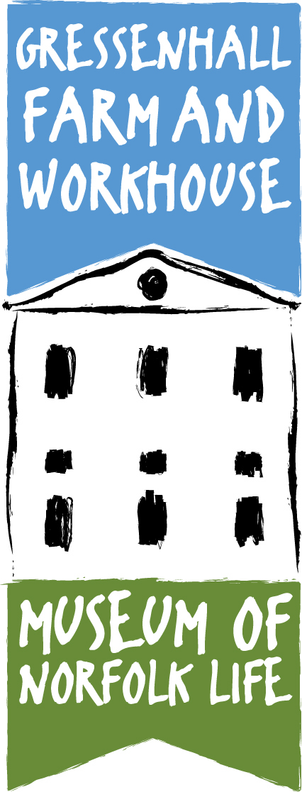

Expression of Interest Form
School visits to Gressenhall Farm and Workhouse

About you

School

Contact person

Title First name Surname

Job title Daytime phone no.

Mobile no. Email

This information may be given to museum staff to help organise your visit.

Booking details

Your requirements
Activity /workshop

Preferred date of visit
First choice
Second choice
Third choice

NB Advance booking is essential. We’ll do our best to give you one of these dates but cannot guarantee to do so.

Number of students in group Key stage Year group

What happens next?
Please save and return your completed form to Katie Sheard at gressenhall.museum@norfolk.gov.uk

Katie will liaise with you to finalise booking details. She will then send you a confirmation form and a booklet with useful information to help ensure your visit is a success.

