This document is in a Word format for you to edit and adapt to suit your purpose.
Entrance and Reception
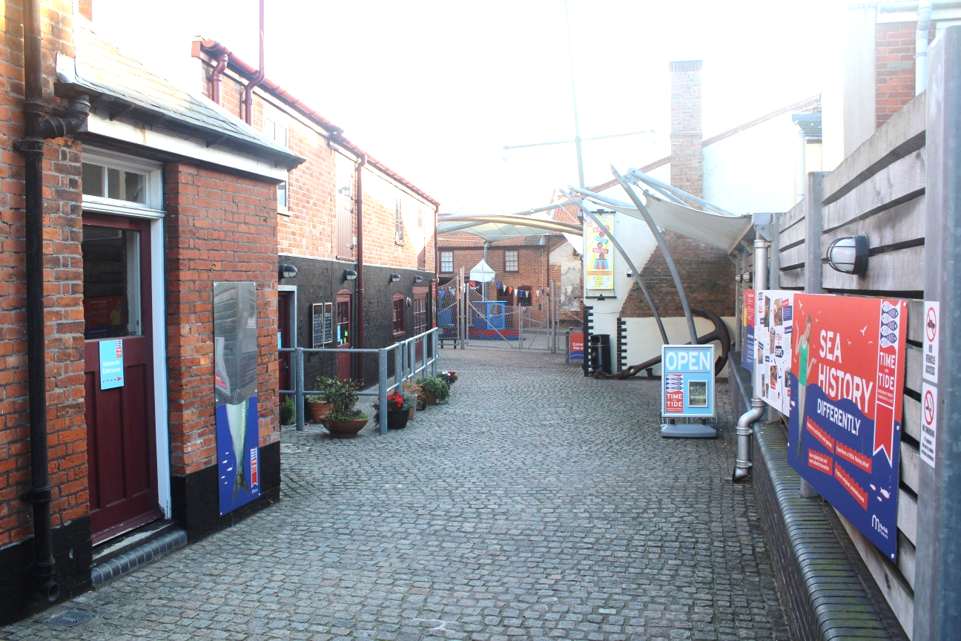

This is the courtyard leading to the Time and Tide reception desk. There is a café to the left where you can buy drinks, snacks and hot or cold meals.

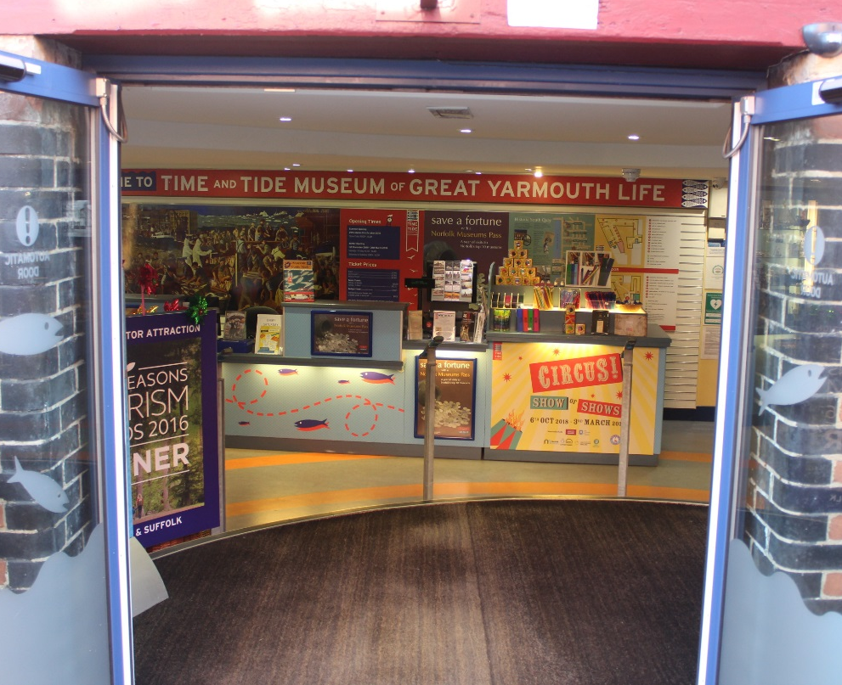

Enter the reception desk through the automatic doors. Here you can get advice about your visit and buy your ticket.

Lighting
Throughout the museum the galleries, including the corridor leading to the reception toilets, have sensor lights which will switch on as you approach.
Toilets, Lockers, and Buggy Storage

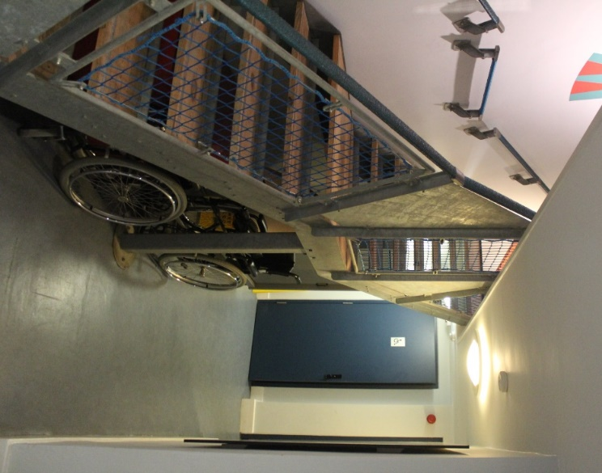
Behind the reception desk you will find space for buggies and lockers to store your belongings during your visit.

Also in this area there are male and female toilets and a separate wheelchair accessible toilet.

All Time and Tide toilets have hot air hand dryers and there is a baby seat in both the male and female toilets.
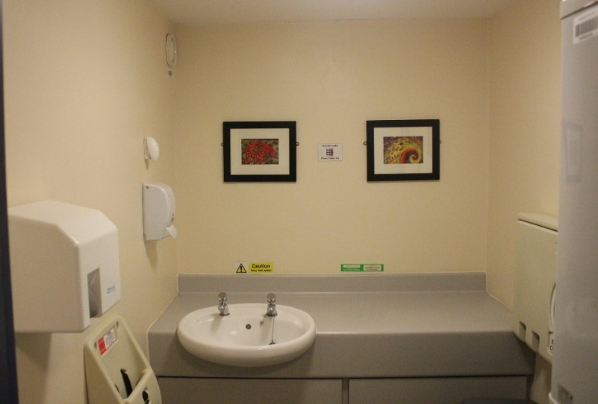

Baby Change
A separate baby changing room, with a baby shelf, seat and is located behind the reception desk.

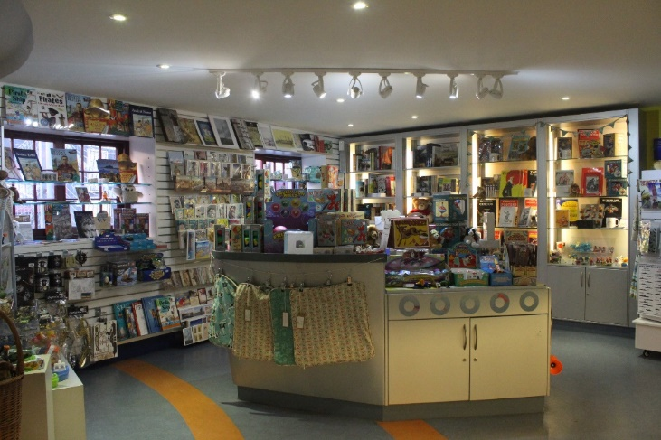

Gift Shop
The gift shop is in front of the reception desk.

The Rows
As you leave the reception area through the automatic doors, the recreated Rows are on the right. Life-size models and a street soundtrack add to the atmosphere in this narrow gallery.
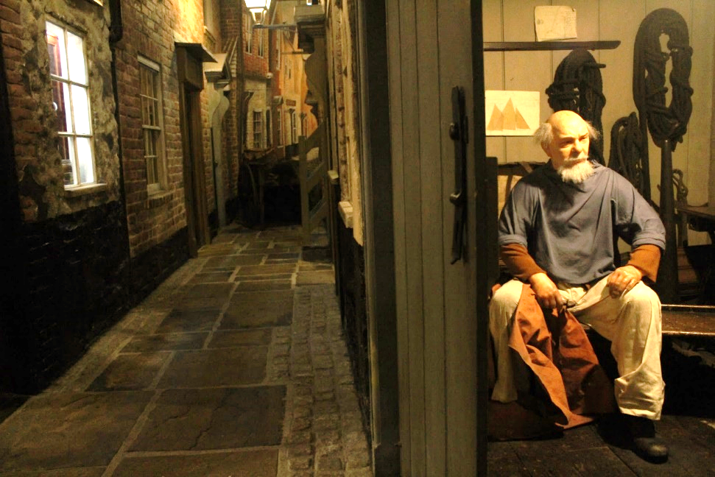

Ground Floor Galleries
You will find the entrance to the Quayside gallery across the inner courtyard.
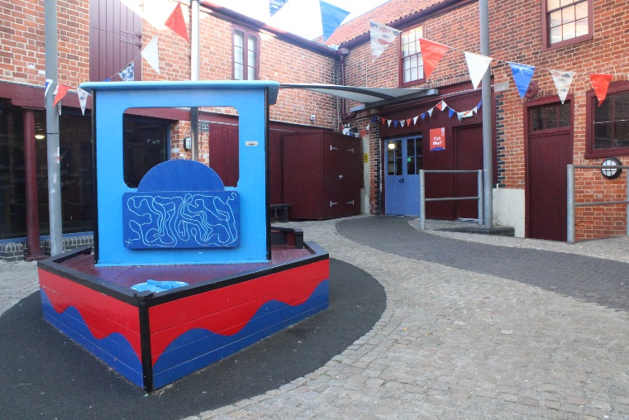
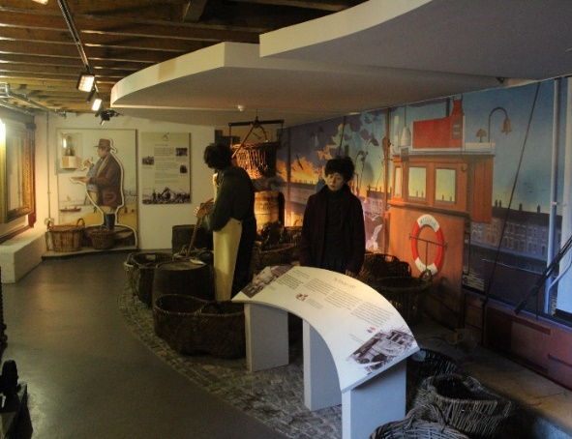
This realistic Quayside diorama uses models and a maritime soundtrack to enhance the scene.

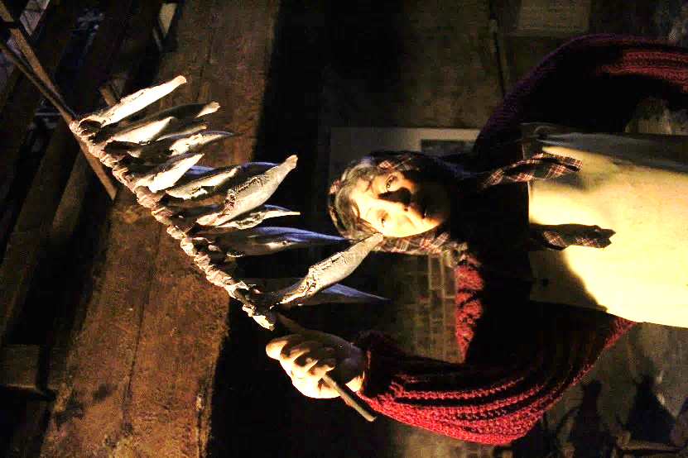
In the ground floor fishing gallery you can learn about the local fishing industry.
The smell of smoked herring is present in the residue on the walls, especially in the third smoke stack where two mannequins, one high up in the stacks, demonstrate part of the smoking process.

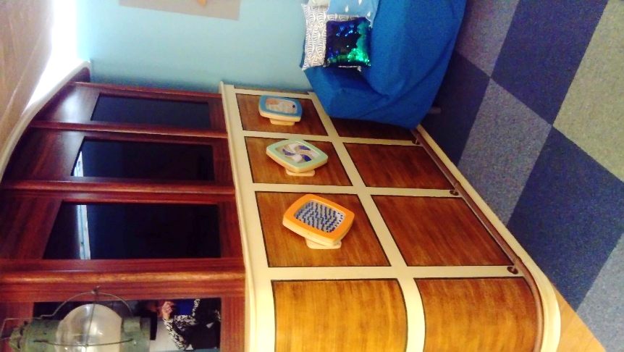

There is a small Cosy Corner between the end of the play boat and the model ship display case. You can use this space to take time out during your visit.

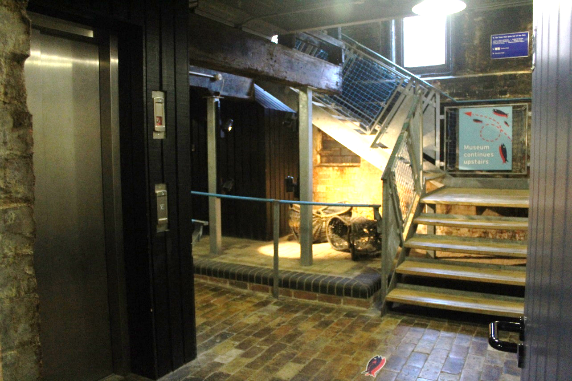

In the landing there is a lift and stairs to the first floor. The stairs are open with net side panels.

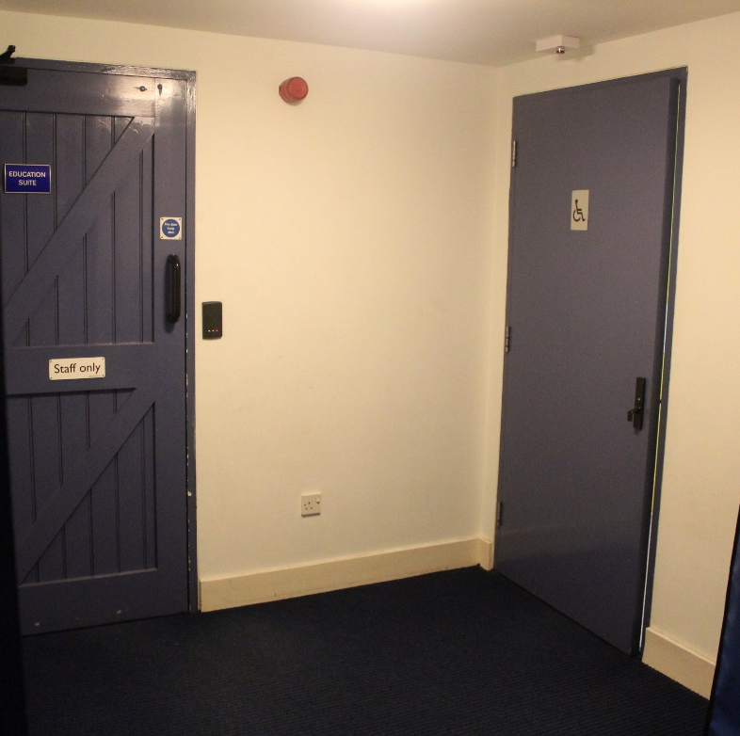

At the top of the landing is a wheelchair accessible toilet with a baby changing shelf.

First Floor Galleries

As you enter the first floor gallery there is a life sized representation of a pre-historic man.
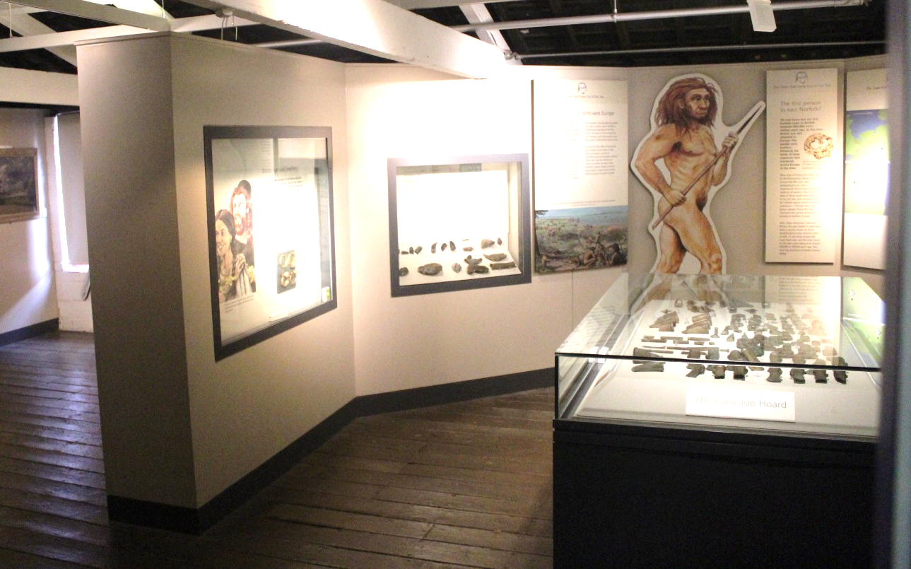
On this floor you will also discover a picture of a Roman soldier and a replica shrouded corpse in an Anglo Saxon coffin.

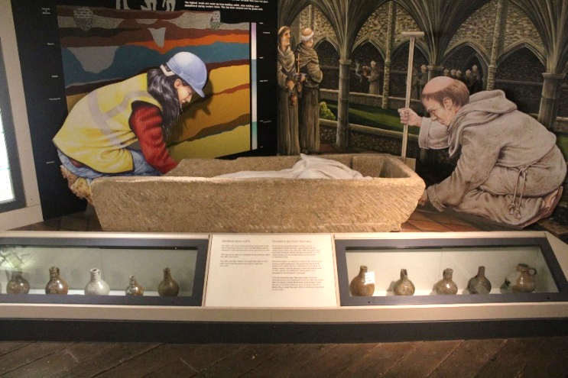

On the left side of this gallery you can enter the mezzanine space and look down on the smoke stacks from above.

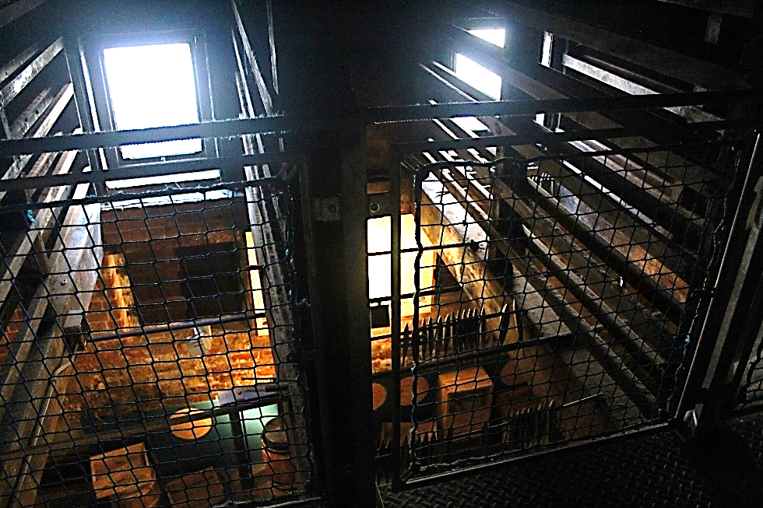

The Wreck and Rescue gallery is set back from the main gallery and continues around the corner.

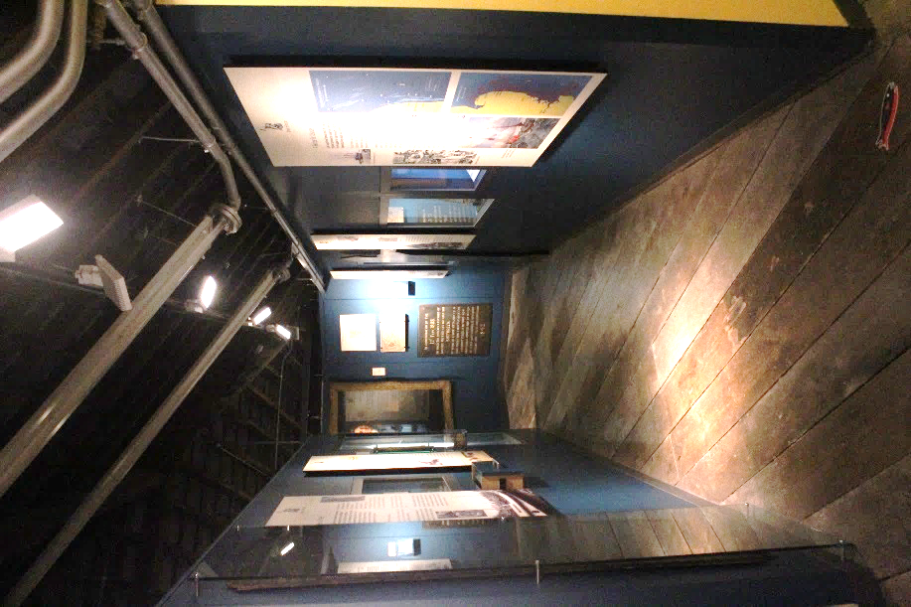

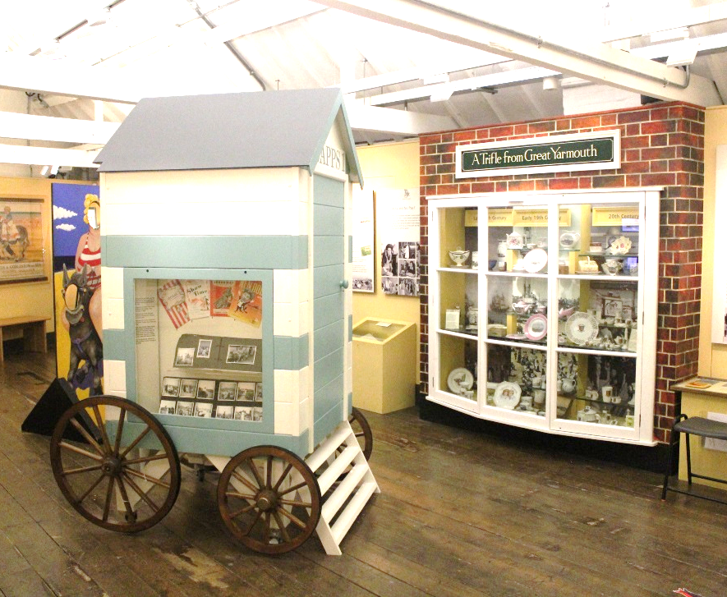
The Seaside Gallery has a sound track to complement the nostalgic seaside exhibits.

In the Town at War gallery there are original weapons which were used in both WWI and WWII. There is also a viewing area with short film on a loop.
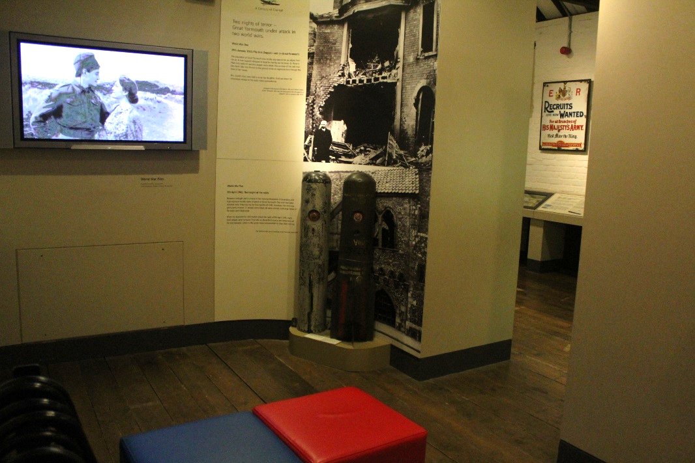

As you leave the Town at War gallery you will enter the Century of Change area. Included in the colourful displays of late 20th Century objects is an old-style telephone which often rings to invite visitors to share memories.
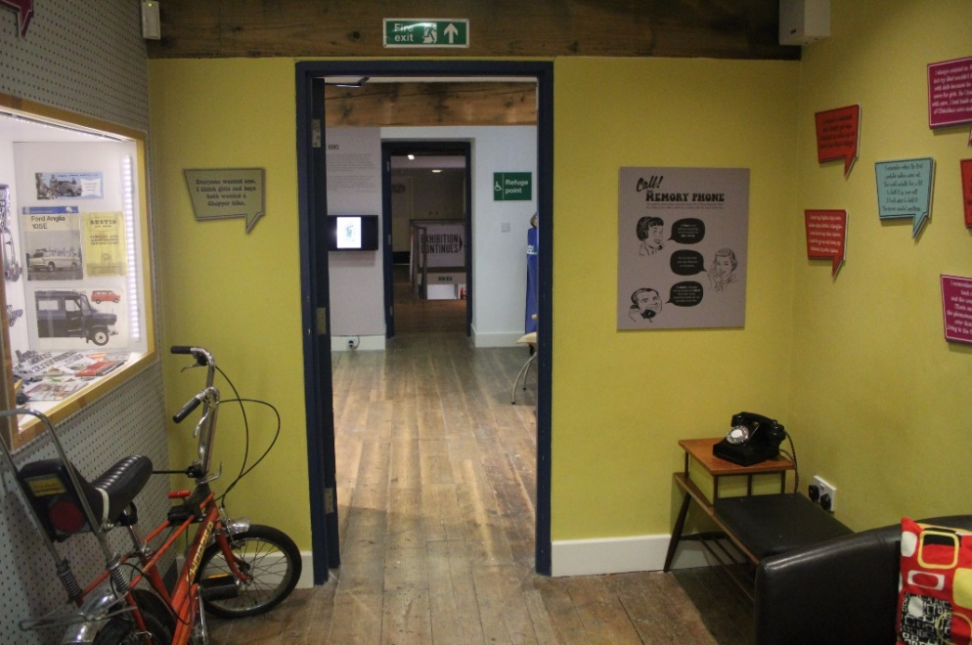

At the end of the gallery is a temporary exhibition space the contents of which regularly change. To find out more about current exhibitions visit www.musuems.norfolk.gov.uk
Lighting is often kept at low levels in this area for conservation reasons.
N:\Museums\GREAT PLACES\Making Waves - Seaside Heritage\Access\Access Pack and Related Docs

